Ana-Maria Piso: Hubble Fellowship Application Statement

**The Role of Disk Volatile Chemistry and Dynamics in Shaping the Compositions of Nascent Planets**

Within the last two decades, more than one thousand extrasolar planets (exoplanets) have been discovered (Batalha 2014). Their diversity in terms of mass, radius, location and composition (Lissauer et al. 2014) provides an exciting field of research, with the eventual goal of finding planets that are similar to our own Earth and may sustain life. For this purpose, it is thus crucial to explore and understand how planets obtain their compositions. Both terrestrial and giant planets are born in protoplanetary disks, which implies that their **composition is determined by and tightly linked to the structure and composition of the disk**. The chemical and dynamical evolution of disks, as well the formation and composition of giant planets have both been previously investigated, but the disk-planet connection has not yet been considered in detail. As shown in my work on the minimum core mass of gas giants (Piso & Youdin 2014, Piso, Youdin & Murray-Clay 2015), planet formation depends sensitively on disk physics and chemistry**. I propose to develop a holistic chemo-dynamical framework to explore how disk dynamics and chemistry, as well as the dynamics of nascent planets and planetesimals, regulate the compositions of mature giant planets.** Such a model will enhance our understanding of planetary structures by enabling us to predict what kind of planet compositions result from planet formation in different parts of the disk. Furthermore, this work provides **essential context for characterizing the planets that instruments such as the James Webb Space Telescope (JWST) and the Transiting Exoplanet Survey Satellite (TESS) will one day discover**. Characterizing the composition of planetary atmospheres is therefore an essential component for understanding the observations of **NASA’s Cosmic Origins Program**.

**1. Coupled Chemical and Dynamical Disk Evolution**. Chemical and dynamical processes in a protoplanetary disk affect the disk structure and composition, and thus the composition of nascent planets. Chemical abundances vary significantly across a typical disk, due to steep gradients in temperature, density and radiation. Figure 1 shows a theoretical example of how both changes in disk temperature, as well as time evolution, decrease the abundance of carbon monoxide (CO) by several orders of magnitude (Aikawa et al. 1996). The complexity of disk chemistry means that coupling it with dynamical processes is non-trivial. Through **analytical and numerical calculations**, I will first explore a **range of dynamical processes that may affect the distribution of volatiles in disks**, expanding and generalizing the framework I developed during my dissertation research (Piso, Öberg, et al. 2015). I will couple this dynamical model with a simple chemical network, then use more complex chemical networks to develop a **simplified time-dependent chemistry**, informed by results from state-of-the-art disk chemistry models (that can only be run on static disks). This will show how the **snowline locations of volatiles**, as well as the **chemical composition of the disk gas and dust evolve**, which has **direct implications on the compositions of young planets**.

Ana-Maria Piso: Hubble Fellowship Application Statement

**2. Planet and Planetesimal Migration**. Giant planets can migrate through the disk while still accumulating gas. Figure 2 shows the first observation of a planetary gap in the disk around TW Hya (Debes et al. 2013). This will change their atmospheric composition since the disk chemical abundances are different at different disk locations. Additionally, giant planets may still accumulate planetesimals while accreting nebular gas (Öberg et al. 2011). The final composition of a planet’s atmosphere will thus depend on how much gas and solids are accreted in this stage. **I will add planet dynamical effects such as migration and planetesimal accretion in the chemical and dynamical model developed in part 1, and quantify how these processes affect the chemical composition of gas giant envelopes**.

**3. Model Planet Populations**. The results from parts 1 and 2 will feed into a **large planet synthesis model**, in which I will use a grid of different i**nitial disk and planetary embryo conditions**. For this computationally expensive step, I will only include the **processes that I have identified to be the most important in the local simulations from steps 1 and 2**. This will allow me to **constrain a planet’s formation location based on its chemical composition**. Comparing my results with current observations of atmospheric spectra (e.g., Figure 3 from Swain et al. 2008), and more importantly **future JWST observations**, will lead to **great scientific strides in understanding the complex connection between protoplanetary disks and the formation, evolution and composition of exoplanets**.

**Proposed Host Institutions**

**1. Massachusetts Institute of Technology (MIT)**

I believe MIT to be the best place for me to pursue my postdoctoral research, due to its vibrant community of experts in exoplanet atmospheres and dynamics, both in the Physics and Earth and Planetary Sciences (EAPS) departments. In particular, I would like to collaborate with Sara Seager, who is a co-investigator of the TESS mission and a world-leading theorist in atmospheric chemistry, as well as with members of her group, who specialize in a broad range of exoplanet theory and computational topics. I would also love to work with **Hilke Schlichting** (proposed faculty host), a leader in planet formation theory and dynamics. Finally, in order to connect my theoretical work with observations, I would like to collaborate with Joshua Winn, who is an expert in discovering and characterizing exoplanets.

**2. University of Chicago**

The University of Chicago would be an ideal place for me to undertake my proposed research, due to its opportunities for valuable collaborations with experts in

Ana-Maria Piso: Hubble Fellowship Application Statement

protoplanetary disks and exoplanets, both in the Department of Astronomy and Department of Geophysical Sciences. **Fred Ciesla** (proposed faculty host) is an expert in protoplanetary disk dynamics, as well as chemical composition and evolution. Leslie Rogers, who will begin her faculty appointment in Fall 2016, is a leader in exoplanet theory, specifically planetary interiors and atmospheres, so I would love the opportunity to collaborate with her on my postdoctoral work. Additionally, the University of Chicago Department of Astronomy hosts leaders in detecting and characterizing worlds outside the Solar system, such as Dan Fabrycky and Jacob Bean, which presents great prospects in connecting my theoretical research work with observations.

**3. University of Michigan**

The University of Michigan would be an excellent place to pursue my postdodcotral research due to its plethora of protoplanetary disks and exoplanet experts. **Edwin Bergin** (proposed faculty host) is an expert in modeling protplanetary disk chemistry, so I would greatly benefit from collaborating with him on this part of my proposed research. I would also love to collaborate with Emily Rauscher, who is a leader in theoretical studies of exoplanet atmospheres. Additionally, the University of Michigan Department of Astronomy has strong ties with the Physics Department, where I would like to collaborate with Fred Adams, an expert in circumstellar disk dynamics and exoplanet theory.

**References**

Aikawa, Y., Miyama, S. M., Nakano, T., & Umebayashi, T. 1996, ApJ, 467, 684

Batalha, N. M. 2014, Proceedings of the National Academy of Science, 111, 12647

Debes, J. H., Jang-Condell, H., Weinberger, A. J., Roberge, A., & Schneider, G. 2013, ApJ, 771, 45

Lissauer J. J., Dawson R. I., Tremaine S., 2014, Nature, 513, 336

Oberg, K. I., Murray-Clay, R., & Bergin, E. A. 2011, ApJ, 743, L16

Piso, A.-M. A., & Youdin, A. N. 2014, ApJ, 786, 21

Piso, A.-M. A., Youdin, A. N., & Murray-Clay, R. A. 2015, ApJ, 800, 82

Piso, A.-M. A., Öberg, K.I., Birnstiel, T, & Murray-Clay, R.M., ApJ, resubmitted after referee report

Swain, M. R., Vasisht, G., & Tinetti, G. 2008, Nature, 452, 329

Ana-Maria Piso: Hubble Fellowship Application Statement

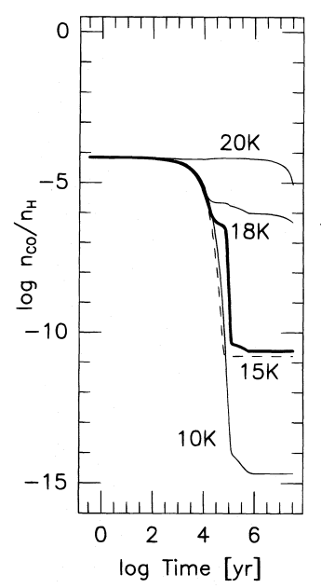

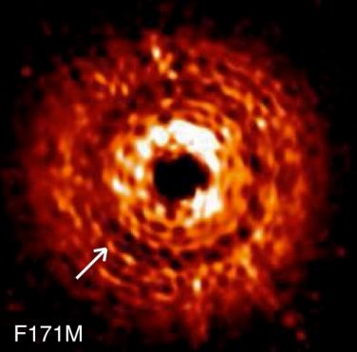

Figure 2: PSF images of TW Hya in band 171M from the Hubble Space Telescope (HST). The arrow shows evidence of a gas gap in the disk, most likely created due to planetary migration (from Debes et al. 2013).

Figure 1: Theoretical model of the time evolution of CO number density in the gas phase as a function of disk temperature (Aikawa et al. 1996).

Ana-Maria Piso: Hubble Fellowship Application Statement

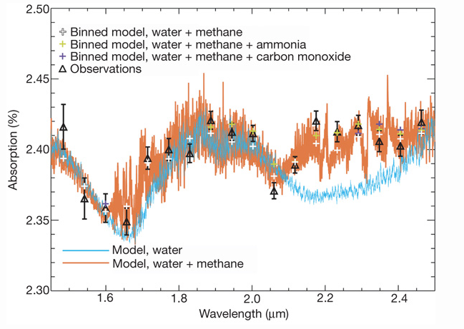

Figure 3: Measured spectrum (black triangles) of the atmosphere of exoplanet HD 189733b, as well as two theoretical model spectra, one containing water (blue curves) and one containing water and methane (orange curves). The comparison between theory and observations shows evidence for methane in the atmosphere of HD 189733b (Swain et al. 2008).